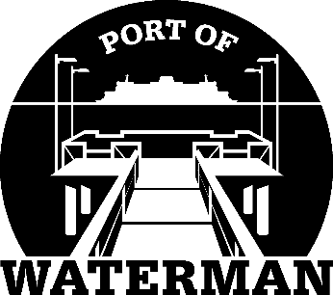

Port of Waterman Meeting Agenda

November 21, 2023

- Review/Approve Agenda

- Review/Approve Prior Meeting Minutes

- Review/Approve Auditor’s Report

- Review Financial Statement

Old Business:

- Maintenance Update

- IT Support/Cameras

- Approve 2024 Budget/Levy

New Business:

- Small Ports Conference Review

- Commissioner District Reports

